Chapter 4. Systematic Review and Meta-analysis of Statistical power surveys of psychological research literatures

**4.1 Introduction**

Since Cohen (1962) showed that articles published in a 1960 issue of the Journal of Abnormal and Social Psychology had a median power of .46 to detect a medium effect, over 60 power surveys have been performed systematically assessing the statistical power of bodies of psychological research. Many of these surveys point to the similarity of their estimates with the average power shown in Cohen’s 1962 paper and argue that there has been no increase in the average power of psychological research despite the repeated published criticism of this fact (e.g., Sedlmeier & Gigerenzer, 1989; Szucs & Ioannidis, 2017). However, no systematic review and meta-analysis has been performed to assess whether this is in fact the case based on all of the available evidence. The current study examines the large body of literature examining statistical power in psychological research, and provides the most up to date systematic review and meta-analysis of the large number of published power surveys which have examined areas of psychological research. This chapter reports a systematic review and meta-analysis of this large body of research to show (a) the average power of psychological research over the last 56 years, as well as (b) how the statistical power of psychological research has been changing over time and (c) whether there are clear differences in average power among subfields of psychology research.

Given that many of the included power surveys suggest that power analysis should be performed as part of research planning, a related and crucial question is whether a higher proportion of research is performing a power analysis as a part of research planning. This study also examines the much smaller body of studies, 17 identified in the current research, that have examined the question of how often published empirical research papers report having performed a power analysis during research planning. This allows for an assessment of (d) how common it is for a power analysis to be reported to have been performed in published psychology research, and (e) whether there has been an increase in the number of papers reporting having performed a power analysis over the last 30 years of psychological research.

**4.1.2 Power surveys**

The included power surveys have typically followed the methods employed by Cohen’s 1962 power survey. Using this approach, a body of published research articles is selected, the statistical analyses performed are extracted along with the sample size included in each analysis. A power analysis is then performed for each analysis using effect sizes equivalent to estimates of “small”, “medium” and “large” effects (see table [effect sizes]). These papers typically use Cohen’s 1977 benchmarks as opposed to Cohen’s 1962 estimates (in which the “small” and “large” estimates were slightly larger, although the medium effect remained at .5 Cohen’s *d)*. The mean power of all of the statistical tests reported in each article is then calculated at each benchmark power level, avoiding weighting individual articles which perform large numbers of statistical tests over individual articles perform fewer tests. The average power of the set of studies is then reported (most commonly often the median, due to the high level of positive skew seen in the distribution of samples sizes). Although some articles deviate from this is small ways (e.g., not averaging the power of each article, only estimating power for the articles “primary analysis”, or only targeting a particular type of analysis such as only examining *t* tests, or ignoring parametric tests), these small deviations seem likely in most cases only to cause small differences in observed power estimates (e.g., (Cashen & Geiger, 2004) showed that not averaging power estimates within articles lead to a difference in estimated power of less than .003).

Table [effect sizes]. Effect size benchmarks following Cohen (1977, 1988, 1992)

|  |  |  |  |
| --- | --- | --- | --- |
|  | Effect size benchmark | | |
| Type of Test (effect size measure) | Small | Medium | Large |
| *t* test on means (*d*) | .2 | .5 | .8 |
| *t* test on correlations (r) | .1 | .3 | .5 |
| F test ANOVA (f) | .1 | .25 | .4 |
| F test for multiple correlation or regression (f2) | .02 | .15 | .35 |
| Chi-square test (w) | .1 | .3 | .5 |

Note. Cohen (1962) used slightly different estimates for small and large benchmarks (e.g., for *t* tests for mean differences *d* = .25 and 1 respectively) although the medium benchmarks has remained the same.

**4.1.3 Examinations of the proportion of studies reporting a power analysis**

Seventeen articles have been identified which provide an analysis of the proportion of studies which justify the sample size they have used with a reported power analysis in the psychology literature. Although it seems reasonable to use the proportion of articles which report a power analysis as an indirect marker of the proportion of studies for which a power analysis was performed during research planning, it is clear that the true rate of performed power analyses will be different. Despite the fact that the American Psychological Association and CONSORT reporting guidelines have suggested that justification for the sample size recruited in research should be provided since at least 2001 (APA Publications Communications Board Working Group on Journal Article Reporting Standards, 2008; D. Moher et al., 2010; David Moher, Schulz, & Altman, 2001; Wilkinson, 1999), it is clear that this is not always done (Fidler et al., 2005). Researchers who have performed a power analysis as a part of research planning may not report their performed power analysis for reasons of word count, or as they may not want to undermine their findings if they had a priori reasons to think that their study may be underpowered.

It is also worth noting that the criteria for being counted as having reported a power analysis is universally liberal among the studies included in this secondary analysis. This means that even articles which explicitly report having performed a post-hoc power analysis, justifying the obtained sample size as opposed to reporting an a priori power analysis performed during research planning, have been counted as having performed a power analysis. Neither did any of the systematic reviews included in this secondary analysis require articles to provide any details about the characteristics of the reported power analysis to be counted as having performed a power analysis. Given the evidence that many of the reported power analyses may not have been accurately performed [Honours research, possibly cite later study here too], the ability of the reported power analyses to inform the selection of an appropriate sample size is unknown. Despite these two issues, it seems reasonable to think that the proportion of studies which report having performed a power analysis is directly related to the proportion of studies in which a formal power analysis was performed in the planning of their research. A large change in reported power analyses either means that the norms around the reporting of power analyses has changed or that the proportion of people who perform a power analysis has increased, either outcome being interesting.

**4.1.4**

This paper analyses the previous studies of statistical power in human behavioral research in order to estimate (a) the average power of published psychological research, (b) whether the average statistical power of psychological research has changed over time at standardized effect size benchmarks (c) whether there are clear differences in average power among subfields of psychology research. Secondarily, this study also assesses the smaller number of studies which have examined the proportion of studies in which a power analysis has been reported in order to show (d) how often power analyses are reported, and (e) whether there has been an increase in the number of papers reporting having performed a power analysis over the last 30 years of psychological research.

**4.2 Method**

**4.2.1 Research Design**

The design and hypotheses, along with a detailed analysis plan for the secondary analysis, were preregistered after an initial pilot sample of 17 articles had been collected, and before any analysis or summary statistics had been calculated. The pre-registration and pilot data is available at <https://osf.io/n6jfd/>. No data imputation or missing handling methods were preregistered, and the [run analysis without any imputed stats here] no other deviations from the planned analyses occurred.

**4.2.2** *Inclusion criteria*

All articles which examine the statistical power of bodies of literature in the psychology literature will be included (broadly defined, including general social, cognitive, occupational, management, clinical, developmental and social psychology, as well as psychiatry, educational and neuroscience research). Articles which analysed the power of fewer than six articles will be excluded in order to exclude studies which targeted a small underpowered body of research. Only articles with full texts available in English will be included. Dissertations and other grey were included if they otherwise met the inclusion criteria. The secondary analysis includes all identified articles which examine a body of research in the same population of psychology research and report the (a) the number of articles examined and (b) the number of articles or the proportion of examined articles which reported a power analysis.

**4.2.3 Record identification**

The sampling strategy was designed to return all reviews of the statistical power of bodies of research in psychological research (broadly defined, including educational, occupational, management, clinical, psychiatry, and neuroscience research). On the 11th of September 2017 the PsycInfo and Medline databases for all records including the words “power*” “sampl*” in their title and "power analysis", "statistical Power" or "sample size" in the main text, identifying an initial 1988 articles.

Hand searches of included articles’ reference lists were performed to attempt to identify any papers detailing power surveys that may have been missed by these search criteria, identifying an additional 18 articles, and one additional article was identified through a google scholar search of “power survey psychology”. After de-duplication 1526 articles remained in the database. This database is available from <https://osf.io/t6jf8/> and some further descriptive analysis of this database can be found at that link or in supplementary material [full search].

*4.2.3.2 Abstract and full text screening*

1432 articles were excluded during abstract screening as they did not report examinations of the power of a body of psychology research. After screening of abstracts, 92 records remained and were subjected to full text screening. During full text screening, 41 articles were excluded. One record was excluded as it was examined the power of published papers in biology, three records were excluded as they were not available in English, four records as their full texts were not available, three as they included data that was reported in other articles included in this survey, and 29 as they did not calculate power for Cohen’s benchmark levels of power. … [further exclusions] … A total of X articles were included in the primary analysis.

Seventeen of these articles also reported the proportion of sampled articles which had reported a power analysis, and were included in the secondary meta-analysis and meta-regression examining the proportion of articles which report a power analysis. Two additional articles were found through reference list searches of these articles which reported the proportion of studies which report having performed a power analysis, and were included in the secondary analysis. A total of 17 articles were included in the secondary analysis. See figure [PRISMA] for a PRISMA flow diagram of article identification, screening, eligibility analysis and inclusion.

## Screening

Full-text articles assessed for eligibility in the primary quantitative synthesis  
(*n* = 92)

Studies included in quantitative synthesis of average power of bodies of research  
(*n* = 50) (length(unique(dat$id)))

Records excluded from this study  
(n = 1416)

*Figure [Prisma].* Prisma flow diagram of article identification, screening and selection. Note that this diagram does note show the selection process for the secondary analysis. The secondary analysis included 17 studies, 15 of which were identified during data eligibility screening for the primary analysis, and two which were identified through reference list searches conducted during data extraction for the secondary analysis.

## Identification

## Eligibility

## Included

Full-text articles excluded

(2 records outside of scope of analysis, 4 were not available in English,   
4 full text not available, three included duplicate data, 15 did not calculate power for a benchmark level of power or report average sample sizes,  
total *n* excluded = 42)

Records identified through hand search of included articles reference lists (*n* = 18)

Records identified through database searching of PsycINFO (Ovid interface, *n* = 916), Web of Science  
Core Collection (*n* = 1072), and Google Scholar search (*n* = 1, total *N* = 1989)

Records after duplicates removed  
(*n* = 1508)

Record abstracts screened (*n* = 1508)

**4.2.4 Data extraction**

The articles included in the primary analysis were examined in randomized order. When additional power surveys were identified during data extraction, they were put aside until the current round of data extraction was complete, at which time all newly identified articles were assessed in random order. The following pieces of information were being extracted from these power surveys: (a) The sampling strategy used, (b) targeted type of statistical tests (e.g., are all tests assessed or just t-tests?), (c) the journals included, (d) the years studied, (e) subfield of research targeted, (f) power estimation technique, (g) whether the power survey distinguishes between different tests, (h) the number of articles included in analysis, (i) the number of tests included in analysis, (j) the unit of analysis of the power survey (i.e., article or statistical test), (k) the effect size benchmarks used, (l) the mean, median, and SD of power at these benchmarks, and (m) the mean, median, and SD of sample sizes.

**4.2.5 Missing data handling**

The range and interquartile ranges of power at small and medium benchmarks was extracted from plots in one article (Smith, Hardy, & Gammell, 2011) using R’s ‘locator’ function (Poisot, 2010), see <https://osf.io/7f2q9/> for the code and output of this analysis. In order to validate the accuracy of this extraction method, median power levels for the medium and small effect size benchmarks for each year were also extracted and compared to the estimates provided in the paper’s text; all six extracted values were within 0.005 of the value provided in the paper’s text.

For seven of the 17 articles in which no IQRs or standard deviations were given, but which displayed cumulative frequency tables, variances were estimated as $σ^{2}=\frac{Σ\left(fx^{2}\right)}{n}{\overline{x}}^{2}$.

$f$ being the frequency of occurrences within each bin, $x$ being the mid interval value (e.g., for the bin .1 - .19, the mid interval value would be .145), $n$ being the total number of values included and $\overline{x}$ being the estimated mean value calculated as $\overline{x}=\frac{Σfx}{Σf}$. An r script with the data extracted from the frequency tables and the working for these estimates can be found at <https://osf.io/7ncke/>. One paper only provided a frequency table at the small benchmark (Cashen & Geiger, 2004). This method was also used to estimate the means of two articles (Haase, 1974; Woolley, 1983) which did not provide means or variances, but which did provide frequency tables. In order to validate this mean imputation method, the difference between the estimated means and the reported means was calculated for all papers for which variances were estimated using frequency tables; the mean absolute difference between the 19 estimated means and the reported means was .017.

(**It may also be possible to estimate it in other ways – consider a Bayesian or likelihood based method**)

When standard deviations were not reported, … [ possibly (Kwon & Reis, 2015)

]

Or (Wan, Wang, Liu, & Tong, 2014)

SEE (Weir et al., 2018) FOR AN OVERVIEW READ THIS !! – also see the post confirmation meeting for a typology of missing data

INPUT TABLE OF MISSING DATA HANDELING HERE

Data extraction for the second analysis used the same randomization procedure as for the primary data extraction. The sampling strategy employed in examined articles, the years included in the paper’s sampling strategy, the area of research the paper sampled from, the total number of articles examined, and the proportion of sampled articles which reported a power analysis were extracted. See <https://osf.io/7ncke/> for data, and Supplementary Material 2 for the codebook as well as a full list of data extracted from articles for both the primary and secondary analyses.

**4.2.5 Analysis**

All data-analysis and coding was conducted using R 3.5.0 (R Development Core Team, 2018) , and meta-analyses were performed using the metafor package (Viechtbauer, 2010). All of the data and code used in these analyses is available at <https://osf.io/as7md/>.

**4.2.5.1 Primary analysis:**

Multiverse checks – Run with different standard deviation imputation procedures

**4.2.5.2 Secondary analysis:**

A random effects meta-analysis was conducted examining the proportion of studies which report a power analysis, and a random-effects meta-regression was performed to estimate the change in power analysis reporting rates over time. Restricted maximum likelihood estimation was used for both analyses. The random effects model was assumed as it is expected this value has (a) changed over time to some degree, and (b) that the bodies of research sampled in the included studies will have different true rates of power analysis reporting (e.g., different journal editors may be more or less likely to request power analysis to be reported, standard in psychiatry may be different than in general psychology, etc.). The median year of the range of studies included in each paper was entered as a predictor in the meta-regression. Proportions were transformed using the Tukey-Freeman Arcsine Transform for both the meta-analysis and meta-regression, as this can act to normalize the sampling distributions of proportions (Miller, 1978). Articles which reported estimates for different year ranges separately in the same paper (e.g., 1980-1982 and 1990-1992) were entered into these meta-analyses as separate entities[1]. Heterogeneity was assessed using the I2, 𝛕2 and Q‐test (Higgins & Thompson, 2002).

**4.3 Results**

**4.3.1 Primary analysis**



Figure (rain). Raincloud plots of median power values at small medium and large effect size estimates following Cohen (1977, 1988).



Figure (rain2) Raincloud plots of mean power values at small medium and large effect size estimates following Cohen (1977, 1988).

SAME AFTER CONVERSION

Sample characteristics:

Bias assessment:

**4.3.2 Secondary analysis**

4.3.2.1 Sample characteristics

A plurality of data points (8 out of 21 data points included) were examinations of clinical research (e.g., examinations of clinical randomized controlled trials of psychological therapies), four examined educational research, three examined management / IO psychology, three neurocognitive/neuroimaging research, two examined general psychology and one examined communication research.

|  |  |  |  |  |
| --- | --- | --- | --- | --- |
| Paper | Years Studied | Subfield | Number of articles examined | Percent Reporting a PA |
| Woods et al., (2006) | 1997-2004 | Clinical | 30 | 0% |
| Thombs & Rice (2016) | 2013-2015 | Clinical | 89 | 3% |
| Ward (2002) | 2000 | Psychology | 103 | 7% |
| Dilullo (1998) | 1975-1994 | Education | 41 | 0% |
| ClarkCarter (1997) | 1993-1994 | Psychology | 54 | 2% |
| Larson & Carbine (2017) | 2010-2015 | Electrophysiology | 100 | 0% |
| Guo et al., (2014) | 2010-2011 | Neuroimaging | 100 | 1% |
| Sedlmeier & Gigerenzer (1989) | 1984 | Clinical | 64 | 0% |
| Short, Ketchen, & Palmer (2002) | 1980-1989 | Industrial-organisational | 149 | 3% |
| Short, Ketchen, & Palmer (2002) | 1990-1999 | Industrial-organisational | 288 | 6% |
| Katzer & Sodt (1973) | 1971-1972 | Communication | 31 | 6% |
| Kosciulek & Szymanski (1993) | 1990-1991 | Clinical | 32 | 3% |
| Osborne (2008) | 1969 | Education | 55 | 0% |
| Osborne (2008) | 1998-1999 | Education | 96 | 2% |
| Woolley & Dawson (1983) | 1977-1980 | Education | 193 | 0% |
| Cashen & Geiger (2004) | 1990-1999 | Industrial-organisational | 43 | 7% |
| Bezeau & Graves (2001) | 1998-1999 | Clinical | 66 | 3% |
| Faulkner, Fidler & Cumming (2008) | 1999-2003 | Clinical | 193 | 18% |
| Crosby et al. (2006) | 1980 | Clinical | 152 | 0% |
| Crosby et al. (2006) | 1990 | Clinical | 152 | 0% |
| Crosby et al. (2006) | 2000 | Clinical | 152 | 2% |

*Note*. See <https://osf.io/gpvbq/> for a brief outline of each articles’ sampling strategy.

4.3.2.2 Meta-analysis results

The meta-analysis shows that a very low proportion of psychology research reports a power analysis, with a meta analytic estimate of 2.6%, 95% CIs [1.2%, 4.3%]. See *Figure [Secondary meta-analysis with exclusions]* for a forest plot of the included studies. Investigation of heterogeneity statistics in the meta-analytic model shows clear evidence of small amounts of heterogeneity in the underlying population parameters, most of which cannot be ascribed to sampling variability alone (𝛕2 .007 (SE = 0.003), I2 = 74.16%, and Q(20) = 95.7, *p* <.001) .

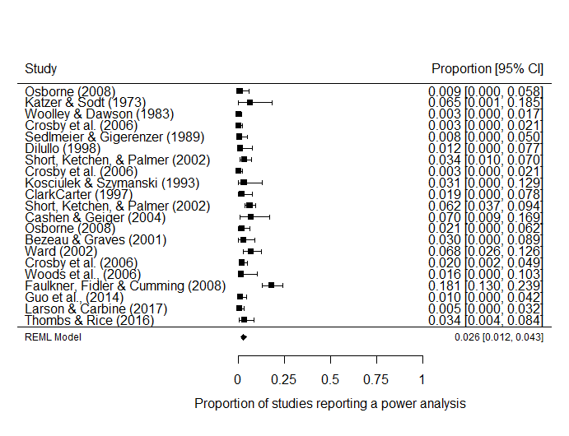

*Figure [Secondary meta-analysis with exclusions]*. Forest plot displaying the findings from seventeen examinations of the proportion of articles which reported a power analysis in psychology research.

4.3.2 Meta-regression

The meta-regression suggests that there has been little to no increase in the reporting of power analyses over time. See Table [Meta-regression] for model summary and *Figure [Secondary meta-regression with exclusions]* for a Meta-regression scatterplot of the effect of time (median year included in each study’s sample) on the proportion of sampled psychology articles reporting a power analysis.

Table [Meta-regression].

*Meta-regression of double arcsine transformed proportions of studies reporting a power analysis by median year covered in each power analytic study*

|  |  |  |  |  |
| --- | --- | --- | --- | --- |
| Predictor | *b* | *b*  95% CI  [LL, UL] | *p* | Fit |
| (Intercept) | -3.00 | [-10.1, 0.18] | .411 |  |
| Year | 0.016 | [-0.002, 0.005] | .384 |  |
|  |  |  |  | *R2* = .012 |
|  |  |  |  | 𝛕2 = .007 (SE = 0.003) |
|  |  |  |  | I2 = .738 |

*Note.* *LL* and *UL* indicate the lower and upper limits of a confidence interval, respectively.

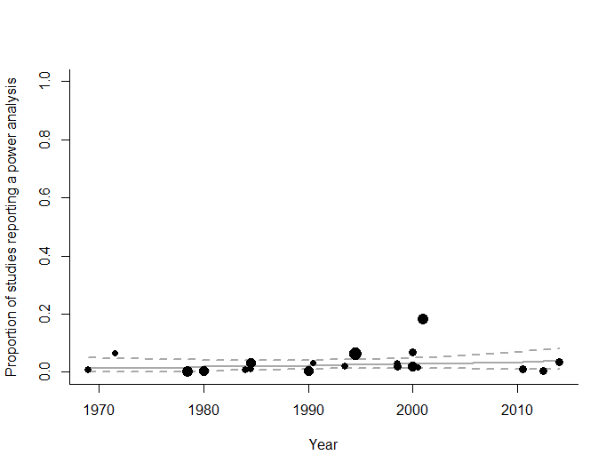

*Figure [Secondary meta-regression with exclusions]*. Meta-regression scatterplot of the effect of time (median year included in each study’s sample) on the proportion of sampled psychology articles reporting a power analysis. Dotted lines are 95% confidence intervals, and the solid line is the estimated proportion of studies reporting a PA, circle sizes reflect the relative number of articles included.

**4.3 Discussion**

**4.3.1 Primary analysis**

…

**4.3.2 Discussion of secondary analysis.**

Power analyses were rarely reported in articles reporting statistical tests in the literature, with a meta analytic estimate of 2.6% (95% CIs [1.2%, 4.3%]) of articles reporting a power analysis. The results suggest that there has been very little to no large change in the proportion of studies reporting a power analysis over time, with an model R2 = .012. This result is unexpected given the large number of studies that have been published arguing for power analysis to be performed as a part of research planning over the last 50 years (e.g., Bezeau & Graves, 2001; Cohen, 1962; Rossi, 1990; Sedlmeier & Gigerenzer, 1989). It is even more surprising given that organizations such as the American Psychological Association and CONSORT reporting guidelines suggest that a justification for the sample size information should be included in published empirical reports (APA Publications Communications Board Working Group on Journal Article Reporting Standards, 2008; D. Moher et al., 2010; David Moher et al., 2001; Wilkinson, 1999).

There are a number of possible explanations for this results that cannot be ruled out on the basis of this data. First, it should be noted a plurality of these the studies included in this secondary analysis are from clinical psychology research (i.e., 10 out of 22 included data points), which is expected to inflate the number of articles reporting a power analysis due to institutional review boards more regularly requiring power analysis if research deals clinical populations (Chan, Hróbjartsson, Jørgensen, Gøtzsche, & Altman, 2008; D. Moher et al., 2010). However, it is also possible that some of these articles were targeted at a particular area of psychology in which power analysis was thought to be rarely reported or performed. Additionally, as the included articles were not primarily being performed to estimate the proportion of articles which reported a power analysis, there is increased risk that only those articles in which the proportion of articles reporting a power analysis were worryingly low reported this value. This may lead to the results of this analysis underestimating the true proportion of studies in psychology that report a power analysis.

Nonetheless, the results are so consistently and extremely low that this analysis provides strong evidence that power analyses are rarely reported across the psychology literature. It is clear that there are multiple populations which have been sampled from in the included studies, as can be seen in the high levels of unexplained heterogeneity in the results of the meta-analysis and meta-regression. However, even the highest reported proportion of studies reporting a power analysis was just 18% (Faulkner, Fidler, & Cumming, 2008). This figure itself is plausibly more indicative of the high number of Psychiatry papers included in their sample, which are expected to have higher rates of reported power than non-clinical psychology research [honors].

The fact that power analyses are rarely reported is not in of itself a problem, as this does not necessarily indicate that power analyses are not being reported, or researchers are performing likely-low power research unknowingly. However, it seems reasonable to suggest that this low rate is indicative of the scarcity of formal sample size planning tools being used. Given that people report having reported a power analysis in around half (49%) the studies in which they performed a power analysis (see chapter ?6?, a survey of psychology researchers’ research planning practices), this suggest that a formal sample size planning is performed in around 5.3% of studies [(.026/.49 = 0.053)]. Although this is far below the self-reported rate of use of formal sample size planning tools (41%, see chapter ?6?), in combination with the evidence that researchers have optimistic intuitions about the likely power of their research (Bakker, Hartgerink, Wicherts, & van der Maas, 2016; Obrecht, Chapman, & Gelman, 2007), the low estimated average power of psychology research, and the low number of reported power analyses, this secondary analysis suggests that large amounts of likely-low power research is being performed unknowingly.

References

APA Publications Communications Board Working Group on Journal Article Reporting Standards. (2008). Reporting standards for research in psychology: Why do we need them? What might they be? *The American Psychologist, 63*, 839-851. doi:10.1037/0003-066X.63.9.839

Bakker, M., Hartgerink, C. H. J., Wicherts, J. M., & van der Maas, H. L. J. (2016). Researchers’ Intuitions About Power in Psychological Research. *Psychological Science, 27*, 1069-1077. doi:10.1177/0956797616647519

Bezeau, S., & Graves, R. (2001). Statistical power and effect sizes of clinical neuropsychology research. *Journal of Clinical and Experimental Neuropsychology, 23*, 399-406. doi:10.1076/jcen.23.3.399.1181

Bland, J. M. (2009). The tyranny of power: Is there a better way to calculate sample size? *BMJ, 339*. doi:10.1136/bmj.b3985

Cashen, L. H., & Geiger, S. W. (2004). Statistical Power and the Testing of Null Hypotheses: A Review of Contemporary Management Research and Recommendations for Future Studies. *Organizational Research Methods, 7*, 151-167. doi:10.1177/1094428104263676

Chan, A.-W., Hróbjartsson, A., Jørgensen, K. J., Gøtzsche, P. C., & Altman, D. G. (2008). Discrepancies in sample size calculations and data analyses reported in randomised trials: comparison of publications with protocols. *BMJ, 337*. doi:10.1136/bmj.a2299

Cohen, J. (1962). The statistical power of abnormal-social psychological research: A review. *The Journal of Abnormal and Social Psychology, 65*, 145-153. doi:10.1037/h0045186

Faulkner, C., Fidler, F., & Cumming, G. (2008). The value of RCT evidence depends on the quality of statistical analysis. *Behaviour Research and Therapy, 46*, 270-281. doi:10.1016/j.brat.2007.12.001

Fidler, F., Cumming, G., Thomason, N., Pannuzzo, D., Smith, J., Fyffe, P., . . . Schmitt, R. (2005). Toward Improved Statistical Reporting in the Journal of Consulting and Clinical Psychology. *Journal of Consulting and Clinical Psychology, 73*, 136-143. doi:10.1037/0022-006X.73.1.136

Haase, R. F. (1974). Power analysis of research in counselor education. *Counselor Education and Supervision, 14*, 124-132.

Higgins, J. P. T., & Thompson, S. G. (2002). Quantifying heterogeneity in a meta‐analysis. *Statistics in Medicine, 21*, 1539-1558. doi:10.1002/sim.1186

Kwon, D., & Reis, I. M. (2015). Simulation-based estimation of mean and standard deviation for meta-analysis via Approximate Bayesian Computation (ABC). *BMC Med Res Methodol, 15*, 61. doi:10.1186/s12874-015-0055-5

Miller, J. J. (1978). The Inverse of the Freeman – Tukey Double Arcsine Transformation. *The American Statistician, 32*, 138-138. doi:10.1080/00031305.1978.10479283

Moher, D., Hopewell, S., Schulz, K. F., Montori, V., Gøtzsche, P. C., Devereaux, P. J., . . . Altman, D. G. (2010). CONSORT 2010 Explanation and Elaboration: Updated guidelines for reporting parallel group randomised trials. *Journal of Clinical Epidemiology, 63*, e1-e37. doi:10.1016/j.jclinepi.2010.03.004

Moher, D., Schulz, K. F., & Altman, D. G. (2001). The CONSORT statement: revised recommendations for improving the quality of reports of parallel group randomized trials. *BMC Medical Research Methodology, 1*, 2. doi:10.1186/1471-2288-1-2

Obrecht, N. A., Chapman, G. B., & Gelman, R. (2007). Intuitive tests: Lay use of statistical information. *Psychonomic Bulletin & Review, 14*, 1147-1152. doi:10.3758/BF03193104

Poisot, T. (2010). Getting data from an image *Data visualization (in R).* Retrieved from <https://rdataviz.wordpress.com/2010/03/05/getting-data-from-an-image-introductory-post/>

R Development Core Team. (2018). R: A language and environment for statistical computing (Version 3.5.0). Vienna, Austria: R Foundation for Statistical Computing. Retrieved from <http://www.R-project.org>

Rossi, J. S. (1990). Statistical power of psychological research: what have we gained in 20 years? *J Consult Clin Psychol, 58*, 646-656.

Sedlmeier, P., & Gigerenzer, G. (1989). Do studies of statistical power have an effect on the power of studies? *Psychological Bulletin, 105*, 309-316. doi:10.1037/0033-2909.105.2.309

Smith, D. R., Hardy, I. C., & Gammell, M. P. (2011). Power rangers: No improvement in the statistical power of analyses published in Animal Behaviour. *Animal Behaviour, 81*, 347-352.

Szucs, D., & Ioannidis, J. P. A. (2017). Empirical assessment of published effect sizes and power in the recent cognitive neuroscience and psychology literature. *PLOS Biology, 15*, e2000797. doi:10.1371/journal.pbio.2000797

Viechtbauer, W. (2010). Conducting Meta-Analyses in R with the metafor Package. *Journal Of Statistical Software, 36*, 48. doi:10.18637/jss.v036.i03

Wan, X., Wang, W., Liu, J., & Tong, T. (2014). Estimating the sample mean and standard deviation from the sample size, median, range and/or interquartile range. *BMC Medical Research Methodology, 14*, 135. doi:10.1186/1471-2288-14-135

Weir, C. J., Butcher, I., Assi, V., Lewis, S. C., Murray, G. D., Langhorne, P., & Brady, M. C. (2018). Dealing with missing standard deviation and mean values in meta-analysis of continuous outcomes: a systematic review. *BMC Medical Research Methodology, 18*, 25. doi:10.1186/s12874-018-0483-0

Wilkinson, L. (1999). Statistical methods in psychology journals: Guidelines and explanations. *American Psychologist, 54*, 594-604. doi:10.1037/0003-066X.54.8.594

Woolley, T. W. (1983). A comprehensive power-analytic investigation of research in medical education. *Journal of Medical Education, 58*, 710-715.

**Supplemental material 1.**

Table [database search].Databases and search terms used for data collection for a systematic review of power surveys performed on psychological research. Search performed on the 11th September 2017.

|  |  |  |
| --- | --- | --- |
| Database | Search terms | Number of records |
| Psychinfo, Ovid Interface | ("*power*" or "Determination" or "estimat*" or "sampl*").m_titl. and ("power analysis" or "Statistical Power" or "Sample Size Estimation" or "Sample Size Determination" or "Sample size selection").mp. | 916 |
| Web of Science Core Collection | SU = (Psychology OR Psychiatry OR "Mathematical Methods In Social Sciences") AND TI = (Power* OR Sampl*) AND TS = ("power analysis" or "Statistical Power" or "Sample Size") | 1,072 |
| Total number of articles |  | 1988 |
| De-duplicated library |  | 1489 |

**Supplemental material 2.**

Coding rules:

* If a paper reports median power estimates separated by year, enter each year’s values into the database separately by year
* For studies which report median power estimates broken down into other categories (e.g., by journal), take the highest level (e.g., the values for the entire sample) at which median power levels are reported. If medians are not reported, record data at the highest level (e.g., “by APA published journals” as opposed to “by journal”)
* If a paper calculates observed power (i.e., power to detect the observed effect size of each study), exclude
* When studies include multiple investigations of the same articles (e.g., studies examining the power of mixed effects study designs to investigate power for main and interaction effects) report the higher estimate.
* If a paper calculates power for meta-analytically derived average, exclude, but retain data
* If a paper calculates power for other values, note and include (but exclude from meta-analysis)
* If power values are stated using multiple effect sizes, record the stated Cohen’s d, but preferably note the source for the estimates (e.g., “Cohen, 1988”)
* Note if an article explicitly notes having used any effect size apart from hedges g (i.e., the effect size that is often called Cohen’s d in papers, but which actually uses Hedges’ estimator)

Supplementary material 3.

Code books for studies:

-

-

-

-

**Supplementary material 4.**

The secondary analysis excluded five studies which did not meet the pre-registered inclusion criteria, but for which data was collected. McKeown et al., (2015), de Bekker-Grob, Bas Donkers, Jonker, & Stolk (2015), Kim (2015), Gaskin & Happell (2014), and Gaskin & Happell (2013), and which examined, respectively, pharmacological and surgical interventions for pain, diverse discrete-choice experiments in healthcare, vision and blindness studies, and two studies which focused on nursing. While these studies do not meet the pre-registered inclusion criteria, as all three articles include some studies which examine psychiatric drugs or treatments for psychological patients it seems appropriate to consider the results of this analysis including these four additional studies.

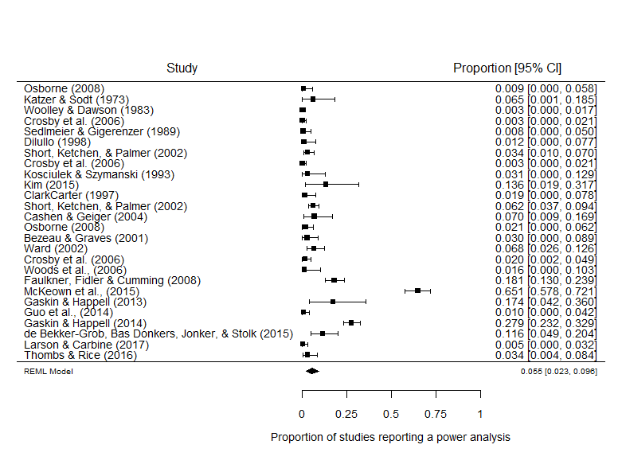

*Figure [Secondary meta-analysis without regression and with medical studies]*. Forest plot of studies examining the proportion of articles which reported a power analysis in psychology research broadly defined. This analysis includes four articles not included in the previous study.

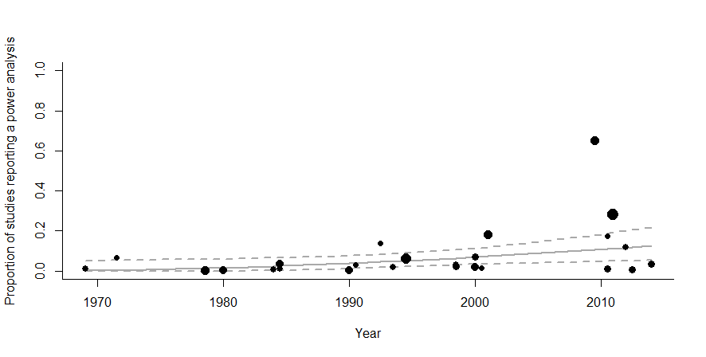

*Figure [Secondary meta-regression with medical studies]*. Meta-regression scatterplot of the effect of time (median year included in each study’s sample) on the proportion of psychology articles reporting a power analysis. Dotted lines are 95% confidence intervals, solid line displays the estimated proportion.

The meta-analytic average proportion of studies which report a power analysis is slightly higher .055, 95% Cis [.023, .096], although the population to which this average applies is unclear. As can be seen in figure *[Secondary meta-regression with medical studies],* a small but statistically significant effect of time can be seen [beta = 0.0065, se = 0.0028, z = 2.2827, *p* = .0224, 95% CI [0.0009, 0.0120]. This would lend support for a pre-registered hypothesis: “The number of articles reporting a power analysis will have increased over time, but is still low (i.e., below 10%).” However, this small increase over time is clearly driven by the much larger proportion of studies which report a power analysis in medical research (Bland, 2009), with 65% of papers reporting a power analysis in McKeown et al., (2015), 28% in Gaskin & Happell (2014) and 17% in Gaskin & Happell (2013), and given that these erroneously included papers happen to be recent, they cause an apparent increase in the proportion of studies reporting a power analysis over time.

**Supplementary Material 5 – Brief literature Overview**

On the 11th of September 2017 a literature search was performed using the PsycInfo and Medline databases in part to collect data for a meta-analysis of the power of psychology research (<https://osf.io/h8u9w/>), but also to allow for a brief overview of the amount and type of articles discussing statistical power in the psychology literature. This supplementary material briefly outlines the procedures used to classify the returned studies, and shows the total number of power surveys, papers giving power sample size determination advice or statistical procedures to estimate statistical power, articles which are conceptual discussions of statistical power, and the number of articles which have assessed the statistical power of statistical procedures under various conditions. Outlining even at this broad level the type and breadth of research that is available discussing statistical power, even just within domain specific fields of psychology, is important in illustrating just how much effort and research has gone into understanding, developing tools to estimate, and discussing statistical power within the field of psychology.

**Method**

**Literature search**

Psych info was searched using the medline interface for the search string *("*power*" or "Determination" or "estimat*" or "sampl*").m_titl. and ("power analysis" or "Statistical Power" or "Sample Size Estimation" or "Sample Size Determination" or "Sample size selection").mp.* This search returned 916 documents. Web of Science was searched using the search string *SU = (Psychology OR Psychiatry OR "Mathematical Methods In Social Sciences") AND TI = (Power* OR Sampl*) AND TS = ("power analysis" or "Statistical Power" or "Sample Size")*, returning 1,072 documents A total of 1988 documents were returned, leaving 1497 after 462 duplicates were removed.

**Article classification**

All 1487 remaining articles’ abstracts were screened and categorized. Full texts were accessed and assessed for applicability when there was ambiguity. All articles which primarily presented methods to plan the sample size of studies were selected.

This search excludes sample size planning articles for novel research paradigms (e.g., power analyses for large research projects). Conference proceedings were excluded. Software announcements were excluded, although articles about software included if they gave any examples of how the program could be used to estimate statistical power. Reanalyses of single previous studies or papers were excluded even if the focus of the reanalysis was on the paper’s likely statistical power.

Articles were classified into 6 groups, (1) power surveys, articles which estimate the statistical power of a group of studies, (2) sample size determination advice or techniques, (3) conceptual discussions of statistical power, (4) analyses of the statistical power of statistical procedures, (5) Analysis of the use of power analysis in a body of literature (i.e., studies which examine how power analysis has been reported and used in a body of literature), and (6) advice or techniques for effect size estimation for power analysis (e.g., articles detailing how to account for publication bias in estimating effect sizes from the published literature).

**Results**

This literature search identified 74 articles examining the statistical power of bodies of literature in psychology, 285 articles examining the power of different statistical procedures and some 478 articles providing methods of determining power or advice for sample size selection, and over 116 published conceptual discussions of statistical power. This database is available from <https://osf.io/t6jf8/>. A meta-analysis of those articles which attempt to estimate the statistical power of a body of research (power surveys), and analyses of the proportion of studies which report a power analysis can be found at (<https://osf.io/h8u9w/>). Although this is by no means a comprehensive overview of psychology research, it does show that there is a large body of research that has gone into discussing, assessing, and attempting to address psychology’s power problem, and provides a database of articles that may be useful to other researchers as a starting point for their own research.

Table SMLO 1.

*Classification of the types of article retrieved. Note that papers can be in multiple groups.*

|  |  |
| --- | --- |
| Type of article | Number of records |
| Articles discussing statistical power | 882 |
| Power surveys | 65 |
| Sample size determination advice or techniques | 432 |
| Conceptual discussions of statistical power | 102 |
| Analyses of the statistical power of statistical procedures | 272 |
| Analysis of the use of power analysis in a body of literature | 14 |
| Advice or techniques for effect size estimation for power analysis | 14 |
| Excluded articles | 607 |

Box SMLO 1. Example papers

|  |
| --- |
| **Power surveys**  Cohen, J. (1962). The statistical power of abnormal-social psychological research: A review. *The Journal of Abnormal and Social Psychology, 65*(3), 145-153.  ClarkCarter, D. (1997). The account taken of statistical power in research published in the British Journal of Psychology. *British Journal of Psychology, 88*, 71-83.  **Sample size determination advice or techniques**  Kelley, K. (2007). Sample size planning for the coefficient of variation from the accuracy in parameter estimation approach. *Behavior Research Methods, 39*(4), 755-766. doi:10.3758/bf03192966  Okumura, T. (2008). Sample size determination for data analysis by hierarchical linear models: An application to a social psychological research using data of TIMSS 2003. *Japanese Journal of Behaviormetrics, 35*(2), 221-228.  **Conceptual discussions of statistical power**  Button, K. S., Ioannidis, J. P., Mokrysz, C., Nosek, B. A., Flint, J., Robinson, E. S., & Munafo, M. R. (2013). Confidence and precision increase with high statistical power. *Nature Reviews Neuroscience, 14*(8), 585-586..  Chase, L. J., & Tucker, R. K. (1976). Statistical power: Derivation, development, and data-analytic implications. *The Psychological Record, 26*(4), 473-486.  **Analyses of the statistical power of statistical procedures**  Engelhardt, W. (1979). Non-parametric testing of interaction: Statistical power analysis. *Psychologische Beitrage, 21*(3-4), 439-449.  Visscher, P. M., & Posthuma, D. (2010). Statistical Power to Detect Genetic Loci Affecting Environmental Sensitivity. *Behavior Genetics, 40*(5), 728-733. doi:10.1007/s10519-010-9362-0  **Analysis of the use of power analysis in a body of literature**  Button, K. S., Ioannidis, J. P., Mokrysz, C., Nosek, B. A., Flint, J., Robinson, E. S., & Munafo, M. R. (2013). Confidence and precision increase with high statistical power. *Nature Reviews Neuroscience, 14*(8), 585-586..  Guo, Q., Thabane, L., Hall, G., McKinnon, M., Goeree, R., & Pullenayegum, E. (2014). A systematic review of the reporting of sample size calculations and corresponding data components in observational functional magnetic resonance imaging studies. *NeuroImage, 86*, 172-181.  **Advice or techniques for effect size estimation for power analysis**  Perugini, M., Gallucci, M., & Costantini, G. (2014). Safeguard Power as a Protection Against Imprecise Power Estimates. *Perspectives on Psychological Science, 9*(3), 319-332. doi:10.1177/1745691614528519  McShane, B. B., & Bockenholt, U. (2014). You Cannot Step Into the Same River Twice: When Power Analyses Are Optimistic. *Perspectives on Psychological Science, 9*(6), 612-625. doi:10.1177/1745691614548513 |

1. Five articles were excluded after the analysis was initially run, as they were found to not meet the pre-registered inclusion criteria, as they were all medical studies. A small increase in the rate of statistical power analysis is seen if these studies are included, as was predicted, but their inclusion has been judged to be inappropriate. See supplementary material 4 for further explanation.